

RED CAPZ’ RESTOBAR DISCO & FAMILY KTV
P30,000.00 Classified Draw Doubles
Dr. A. Santos Ave, Parañaque City

  Sponsored by:  Supported by:    Official Dartboard:   | AUGUST 13, 2011 (Saturday)  ENTRY FEE – P300.00  REG. TIME – 6:30 PM  GAME TIME – 8:00 PM  CASH BREAKDOWN  Mode of Play  Winner’s Bracket – 501 Best of 3  Loser’s Bracket – 701 Single Game | 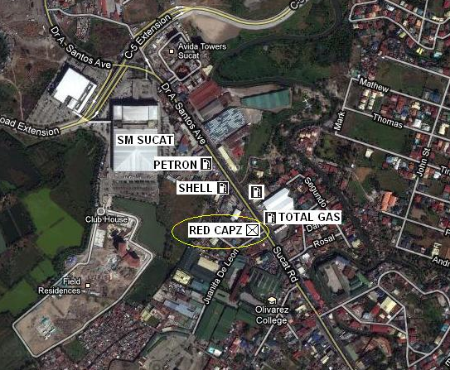  Contact Person:  Rommel Escubil – 0918-4728629  Austin Malamug – 0905-1553469  Ramzy Fernandez – 0928-2819323
  1st  2nd  3rd  4th  Joint 5th – 6th  Joint 7th – 8th  TOTAL | 13,600  7,000  3,400  2,000  1,200  800  30,000

RED CAPZ’ RESTOBAR DISCO & FAMILY KTV
P30,000.00 Classified Draw Doubles
Dr. A. Santos Ave, Parañaque City

Sponsored by:  Supported by:  Official Dartboard: | AUGUST 13, 2011 (Saturday)  ENTRY FEE – P300.00  REG. TIME – 6:30 PM  GAME TIME – 8:00 PM  CASH BREAKDOWN  Mode of Play  Winner’s Bracket – 501 Best of 3  Loser’s Bracket – 701 Single Game | Contact Person:  Rommel Escubil – 0918-4728629  Austin Malamug – 0905-1553469  Ramzy Fernandez – 0928-2819323
  1st  2nd  3rd  4th  Joint 5th – 6th  Joint 7th – 8th  TOTAL | 13,600  7,000  3,400  2,000  1,200  800  30,000

