
San Miguel beer Corporation
Thru Brgy. Capt. Arthur Blanco
OCTOBER darts FEST08

P20,000 CLASSIFIED DRAW DOUBLES
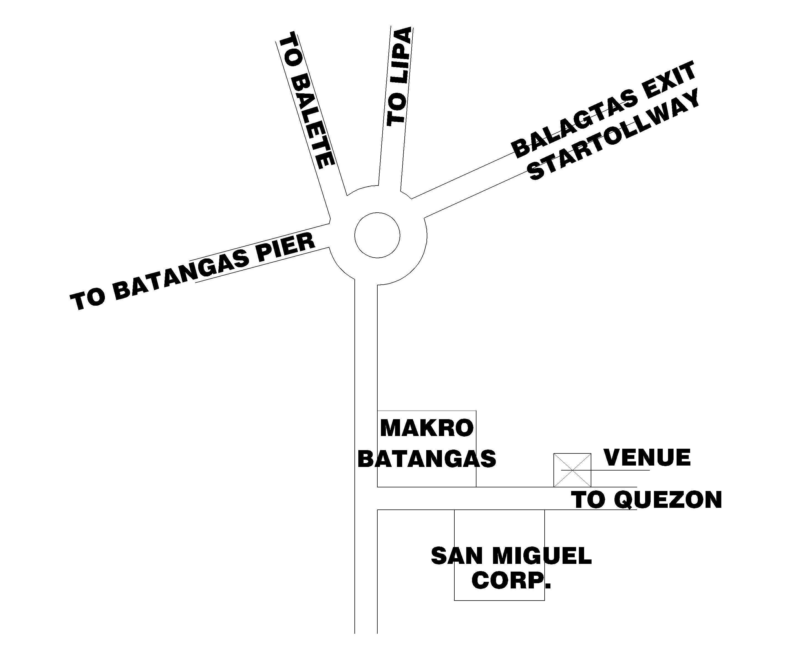
October 26, 2008
Winners | Breakdown
Champion | 9200
2nd place | 4800
3rd Place | 2400
4th Place | 1200
Joint 5th and 6th | 800
Joint 7th and 8th | 400
Total | 20,000
Game format: KOO/701
P1,000 Cash prize for:
Highest High Out & 1st two 170 finish
REGISTRATION TIME: 12:00 p.m.
VENUE:
Dampa Seafoods Restaurant
@ Brgy. Balagtas, Batangas City
Entry fee: P150 w/ 1 free beer
For more info text or call:
Randy Macaraig 0906-795-9788

Organized by: special participation : s u p p o r t e d b y : sponsored by:





