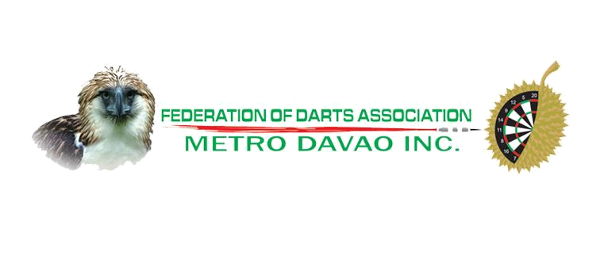

^{1ST} FOUNDING ANNIVERSARY DART TOURNAMENT PHP 25,000.00
NATIONAL DART FEDERATION OF THE PHILIPPINES (NDFP) RANKING EVENT
SANCTIONED BY:
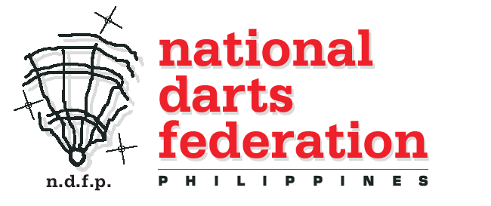
VENUE: BULLS OUT SPORTS BAR AND GRILL
EVENT: | OPEN SINGLES | OPEN DOUBLES
DATE: | OCTOBER 31, 2009 | OCTOBER 31, 2009
ENTRY FEE | 150.00 | 150.00
GAME TIME : | 1:00 PM | 5:00 PM
CASH BREAKDOWN
CHAMPION | 5,000.00 * | 6,000.00 *
2nd Place | 2,500.00 * | 3,000.00 *
JOINT 3rd-4th | 1,250.00 | 1,000.00
JOINT 5th-8th | 500.00 | 500.00
MODE OF PLAY  SINGLE KNOCK-OUT | ELEM. ROUND BEST OF 5, SEMIFINALS  BEST OF 7, CHAMPIONSHIP BEST OF 9

OFFICIAL BOARD:

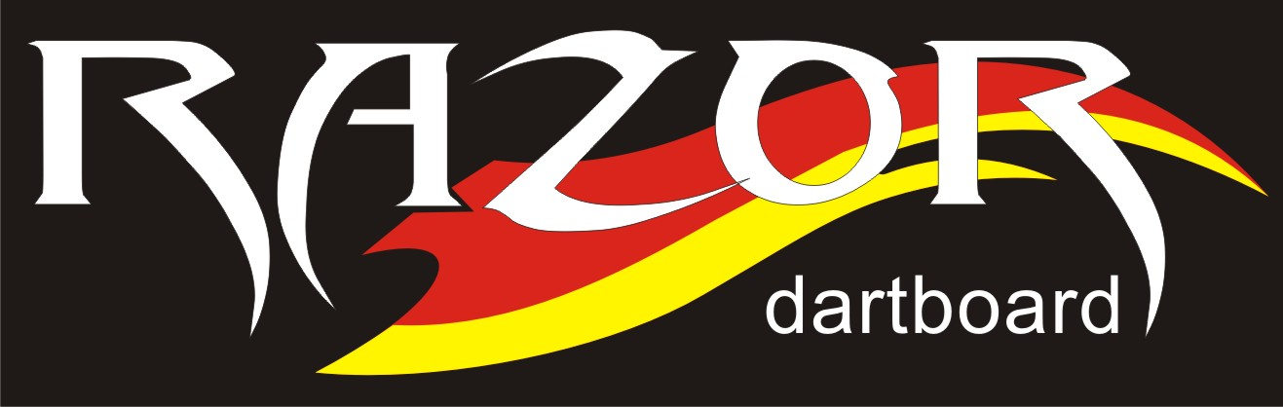

* Trophies to the champions and 2nd placers // 1 Free Beer to all registrants
SPONSORS: TROPHIES BY:
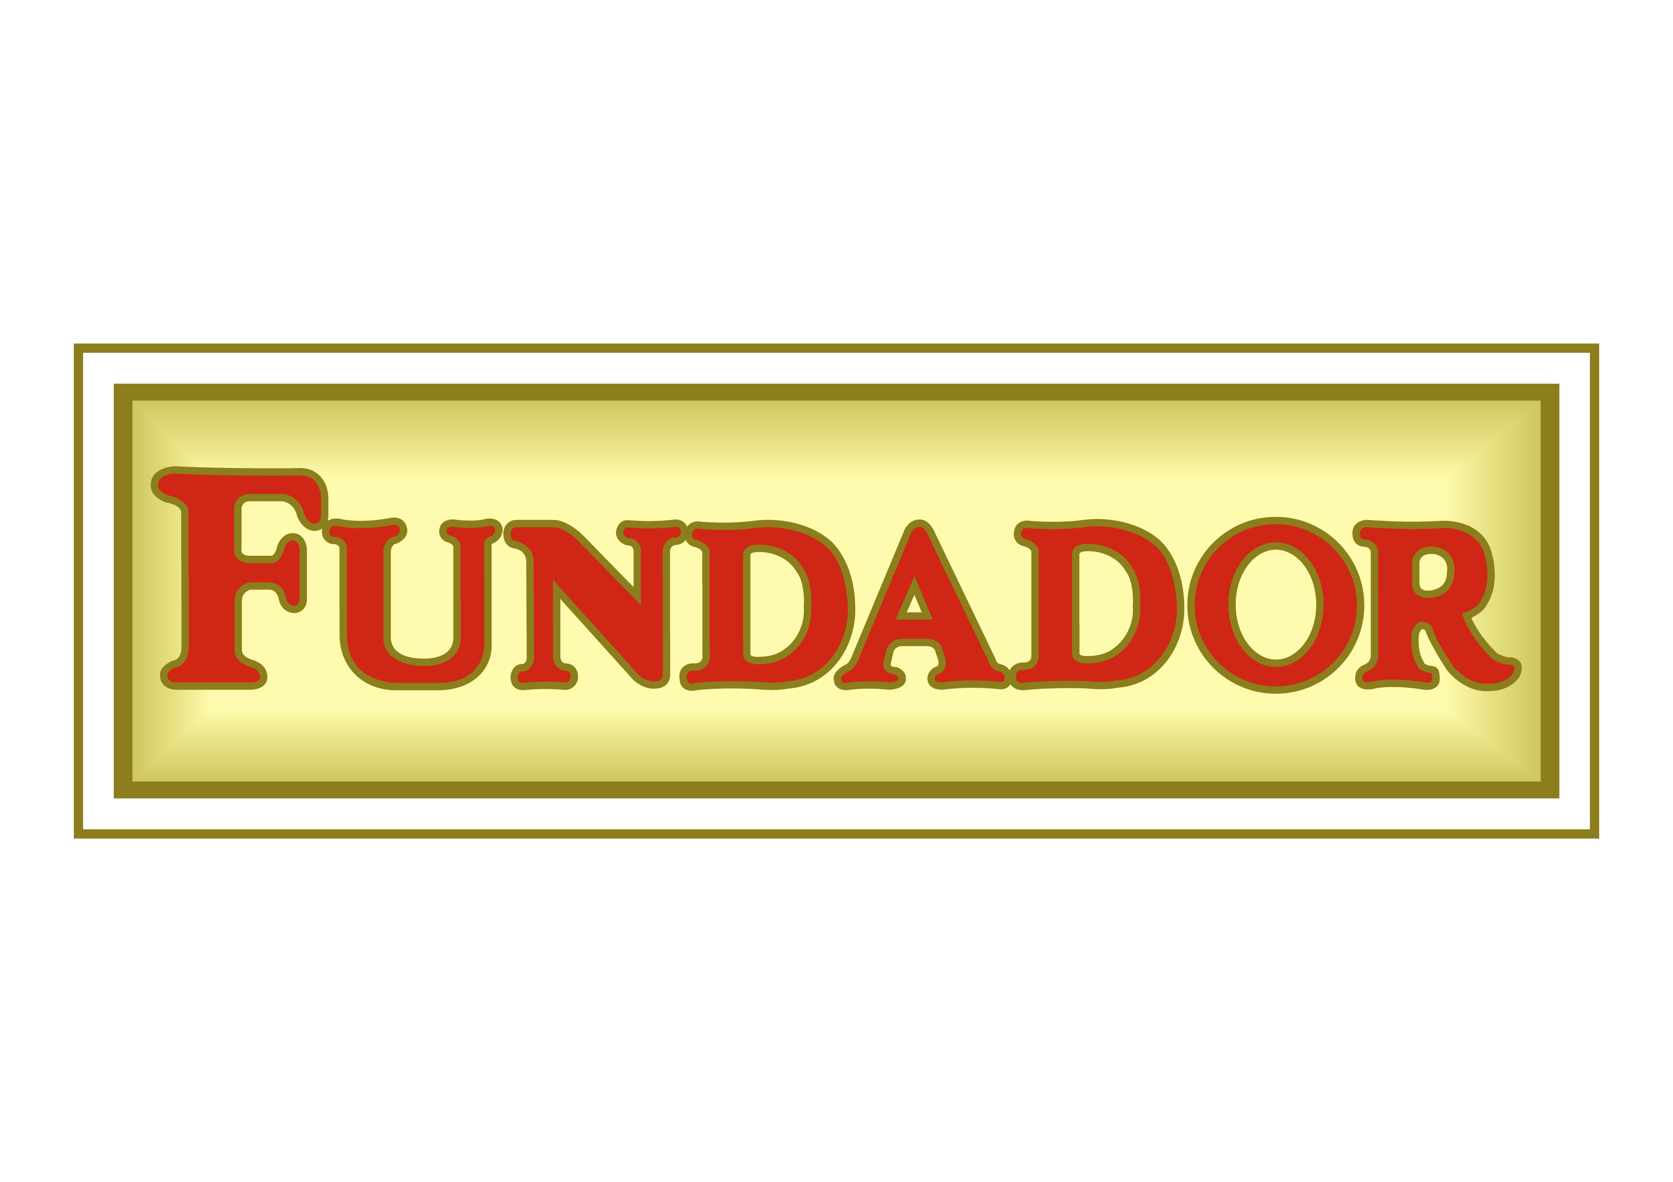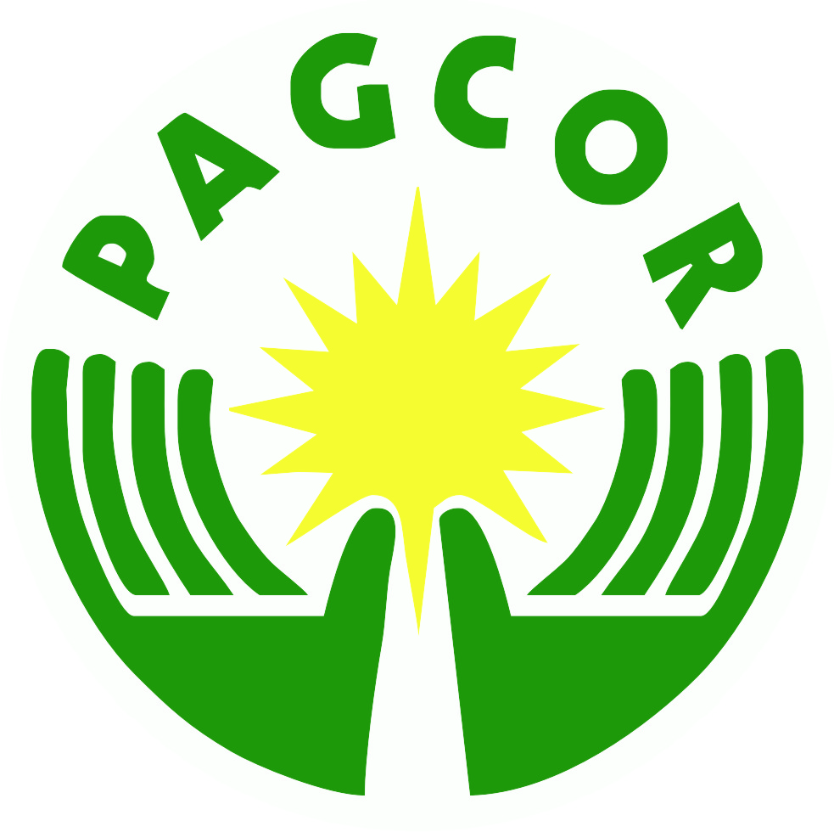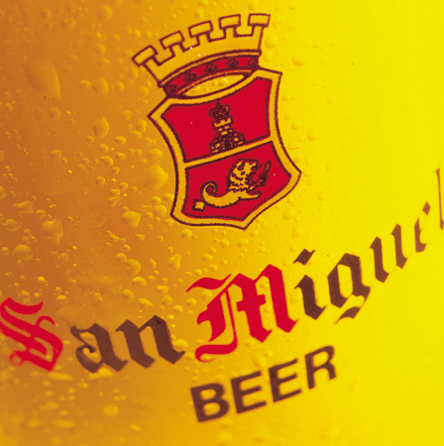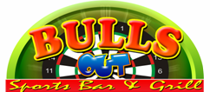

MCDS GENERAL ENGINEERING COLASAS BBQ OXY WATERS RED PALM DINERS
CONSULTANCY

CONTACT PERSONS: BOY GLUDO 09266290696 BOY VILLAMOR 09197262127 JECLE ROSALES 09206325283 ERNIE CEQUIÑA 09174011876 TOTONG SAGUID 0915600829 GARY REFRESCA 09192202249

